# DAILY ONLINE ACTIVITIES SUMMARY

|  |  |  |  |  |  |  |  |
| --- | --- | --- | --- | --- | --- | --- | --- |
| **Date:** | **30-05-2020** | | | | **Name:** | **Apoorva H P** | |
| **Sem & Sec** | **VI A** | | | | **USN:** | **4AL17CS011** | |
| Online Test Summary | | | | | | | |
| **Subject** | | **PAP IA 2 Test** | | | | | |
| **Max. Marks** | | **30** | | **Score** | | **14** | |
| Certification Course Summary | | | | | | | |
| **Course** | **Machine Learning with python** | | | | | | |
| **Certificate Provider** | | | **Congnitive Class** | **Duration** | | | **6hr** |
| Coding Challenges | | | | | | | |
| **Problem Statement:**   1. Python program to read a number and print the pattern. 2. python program to delete an element at the given position. | | | | | | | |
| **Status: Completed** | | | | | | | |
| **Uploaded the report in GitHub** | | | | **Yes** | | | |
| **If yes Repository name** | | | | <https://github.com/ashaapoorva/online-coding-and-certification-course> | | | |
| **Uploaded the report in slack** | | | | **Yes** | | | |

**Online test Detail:**

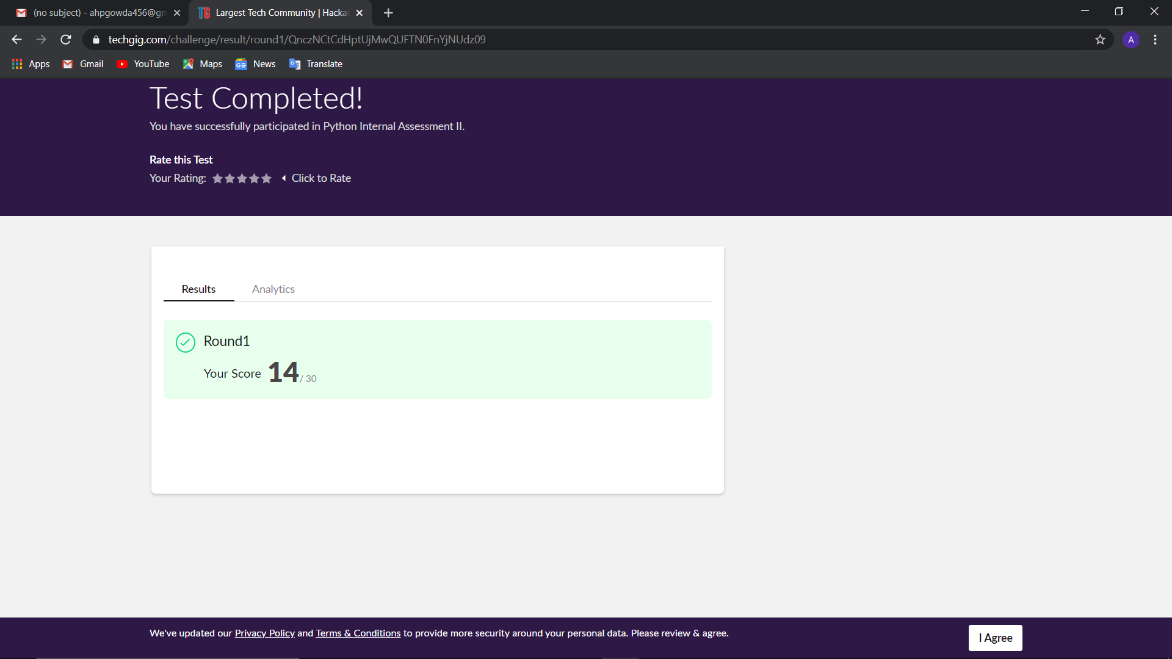

**Online Certification Details**

Modules completed:

-Module 1:Machine Learning

-Intro to machine learning

-Python for machine learning

-Supervised vs unsupervised

-Module 2:Regression

-Intro to Regression

-Simple linear regression

-Multiple linear regression

-Model evaluation

-Evaluation metrics

-Non linear regression

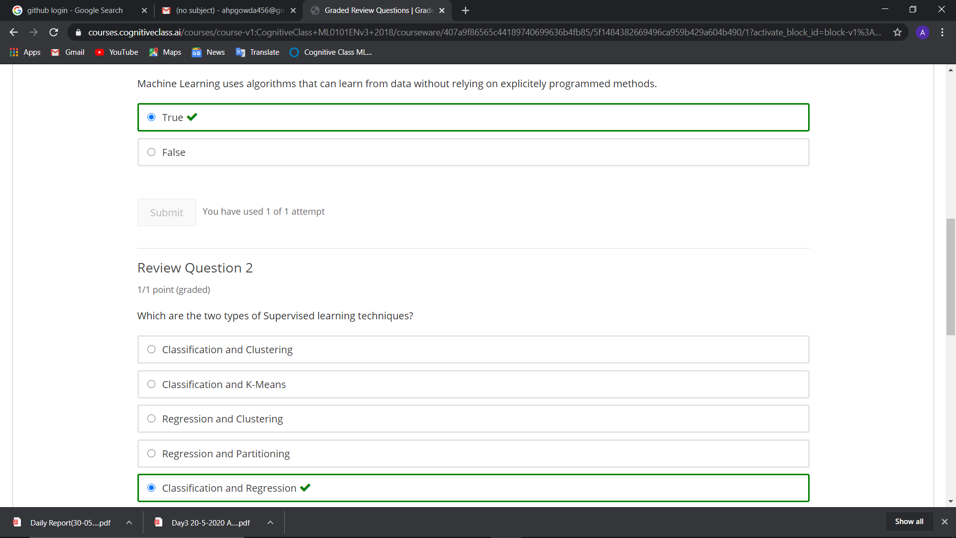

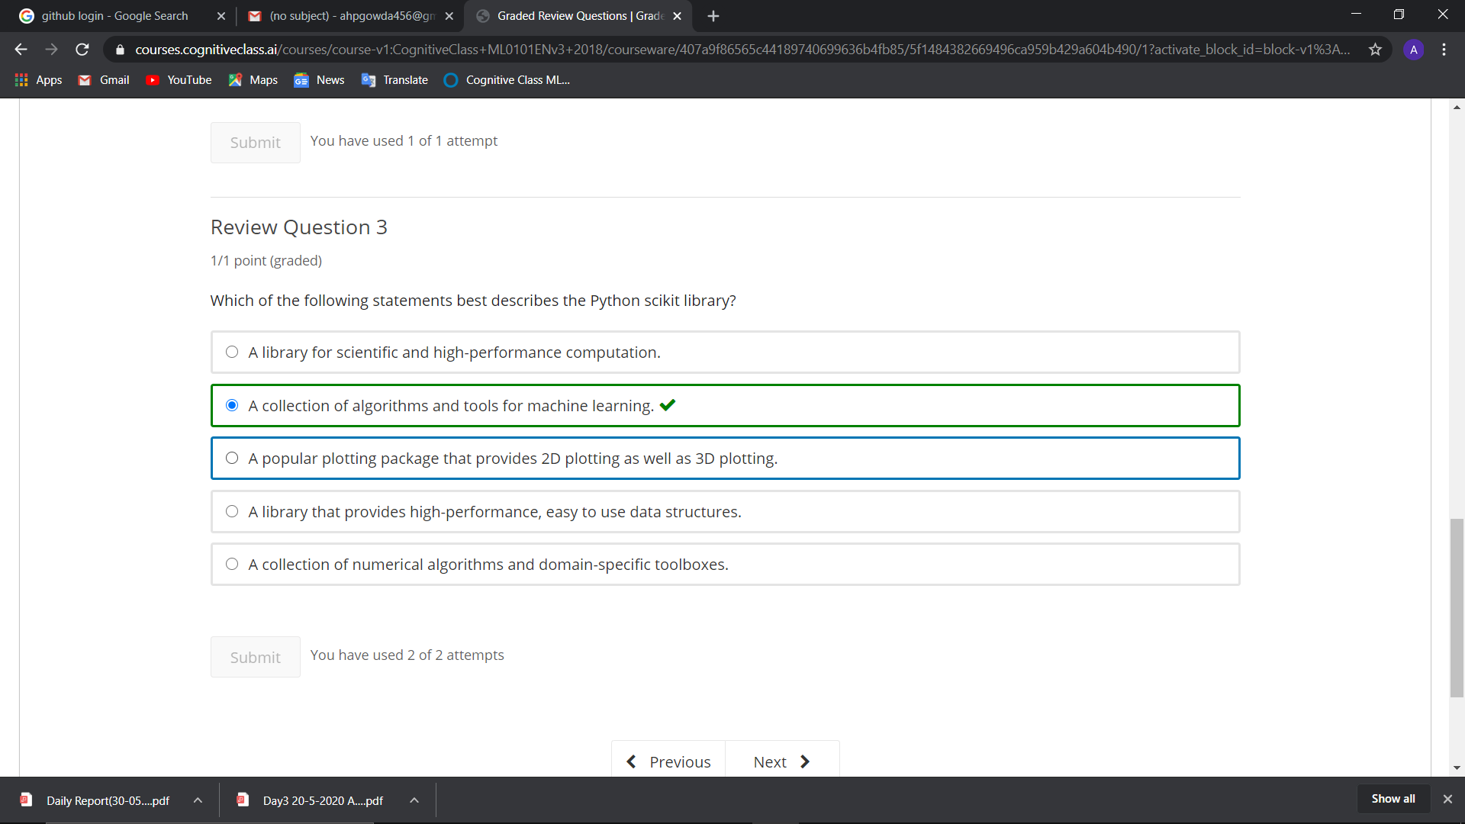

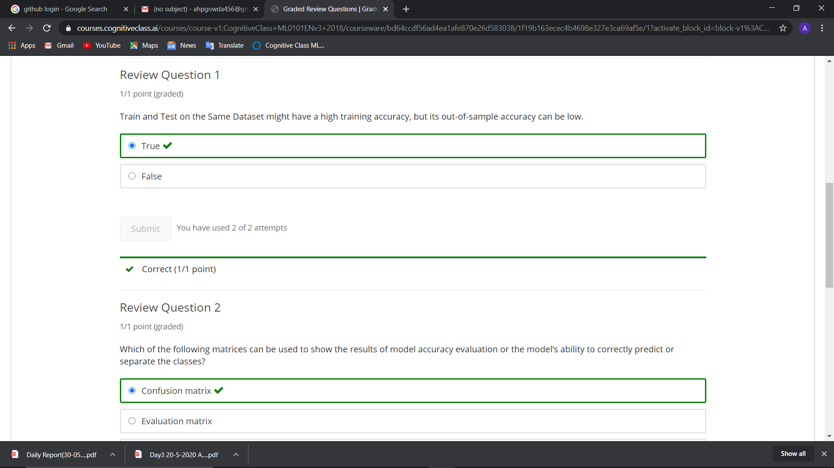

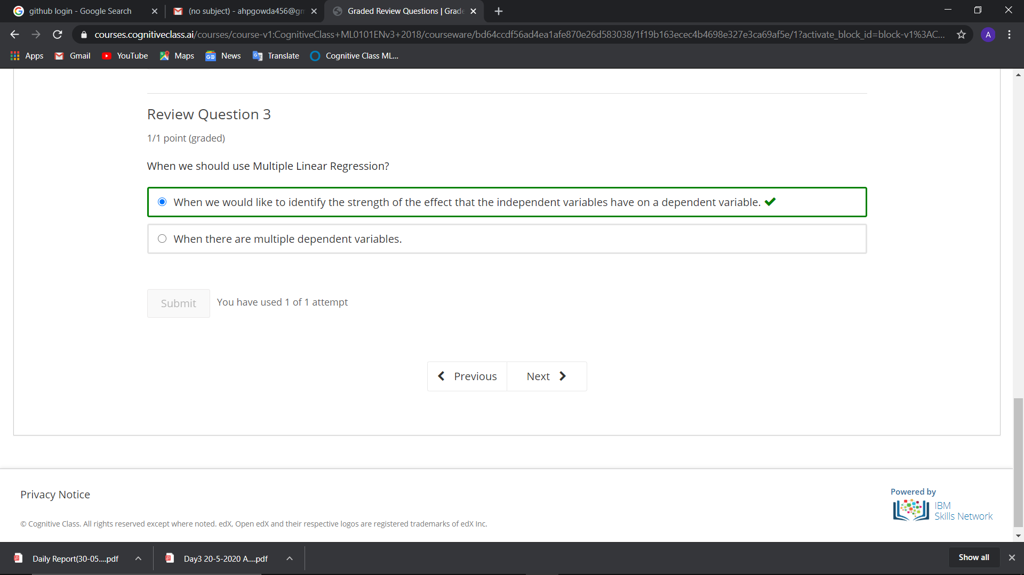

**Coding Challenge Details**

1. Python program to read a number and print the pattern.

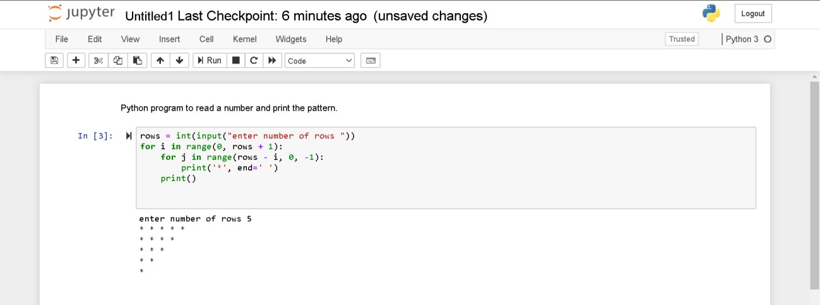

1. python program to delete an element at the given position.

